Module 1 – Overview of IT Industry

**Write a simple "Hello World" program in two different programming languages of your choice. Compare the structure and syntax**

#include <stdio.h>

int main() {

printf("Hello, World!\n");

return 0;

}

• **C** is a **compiled, statically typed** language with more formal structure.

• **Python** is an **interpreted, dynamically typed** language that’s simpler and more readable for beginners.

• C is better for **low-level system programming**, while Python is widely used for **scripting, automation, and rapid development**.

**Research and create a diagram of how data is transmitted from a client to a server over the internet.**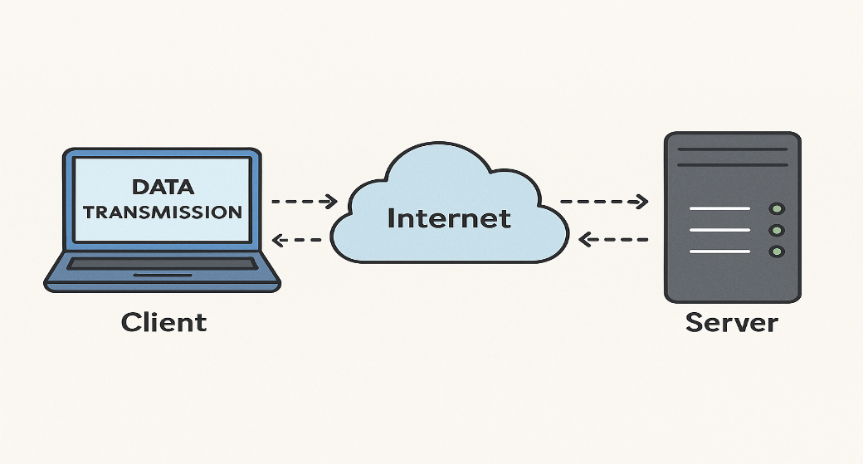

**Steps of Data Transmission from Client to Server**

1. **User Request (Client Side)**
   * A user enters a URL in the browser (e.g., www.example.com).
   * The browser prepares an HTTP request.
2. **DNS Resolution**
   * The domain name is translated into an IP address via DNS (Domain Name System).
   * The client contacts a DNS server to resolve www.example.com to an IP like 93.184.216.34.
3. **TCP Handshake (Three-Way Handshake)**
   * Client initiates a TCP connection with the server using a SYN message.
   * Server replies with SYN-ACK.
   * Client responds with ACK. The connection is now established.
4. **Data Packetization**
   * The HTTP request is divided into smaller **packets**.
   * Each packet contains headers (IP, TCP) and a segment of data.
5. **Routing Over the Internet**
   * Packets are sent through routers, ISPs, and network backbones.
   * They may take different paths to reach the destination.
6. **Firewall and NAT Handling**
   * Firewalls inspect packets for security.
   * NAT (Network Address Translation) rewrites IP headers if needed (e.g., in home networks).
7. **Server Receives the Packets**
   * Server reassembles packets.
   * Data is handed over from the network layer to the application layer.
8. **Server Responds**
   * The server processes the request (e.g., fetches data, runs a script).
   * A response is sent back using the same TCP connection.

**Design a simple HTTP client-server communication in any language.**